**Basic Programming**

Looping 2

Assignment

Case Study 2



MUHAMMAD BAIHAQI AULIA ASY’ARI

2241720145

CLASS 1I (INTERNATIONAL)

INFORMATICS ENGINEERING­­

INFORMATICS TECHNOLOGY

STATE POLYTECHNIC OF MALANG

Contents

Case Study 2 3

FOR 3

WHILE 4

DO-WHILE 5

# Case Study 2

## FOR

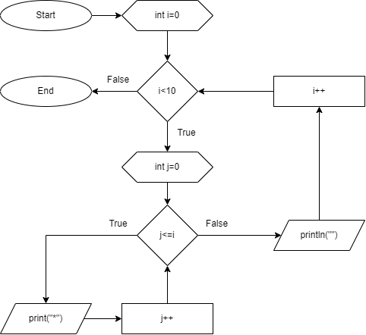

## WHILE

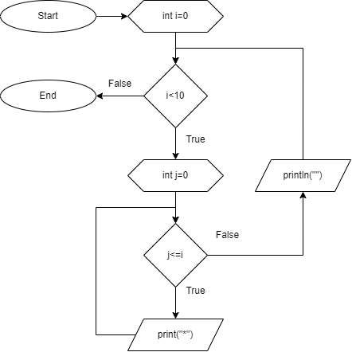

## DO-WHILE

